Prednáška č.1
katarina.lackova@stuba.sk
satko: matematicka analyza 1
MA
pocas semestral 40b za 2 testy v siedmom a desiatom tyzdni
treba aspon 20 bodov
skuska bude urcite pred vianocami v 13 tyzdni

Reálna funkcia jednej reálnej premennej
Zjednotenie U, a zaroven je obratene v, alebo je v atd.
Najdite definicny obor funkcie:
- F(x) =3sqrt(2-ln x)
D(f): X > 0
D(f) = (0, nekonecno)
- g(x) = ln(2cos x – sqrt(3))
2*cos x – sqrt(3)>0
2cos x > sqrt(3)
Cos x > sqrt(3)/2
D(g) = (-pi/6+2kpi;pi/6+2kpi … nestihol som)
- h(x) = sqrt(2-log_{0,5} x)
2-log0,5x >= 0
-log0,5 x >= -2
Log0,5 x <= 2
x>=1/4
a taktiez aj x > 0
D(h)=<1/4,nekonecno)
- i(x) = sqrt(x-1/x+1)
x-1/x+1 >= 0
((x-1) >= 0 a zaroven (x+1)>0) zjednotene (x-1 <= 0 a zaroven x+1 < 0)
(X >= 1 a zaroven x>-1)zjednotene(x<= a zaroven x <-1)
D(i) = (-nekonecno,-1) zjednotene <1,nekonecno)
- j(x) = arcsin(2x+1)
-1<=2x+1 a zaroven 2x+1 <=1
-2<=2x 2x<=0
x>=-1 a zaroven x <=0
D(j) = <-1,0>
Arcus sa pohybujeme v intervale -1,1 (arcsin, arccos I think)
- h(x) = arct(1/sqrt(x^2-4x+3))
x^2-4x+3>0
(x-3)(x-1)>0
x = 3 x = 1
D(h)=(-nekonecno,1)zjednotene(3,nekonecno)

Nakreslite graf funkcie
- f(x) = ln(x)
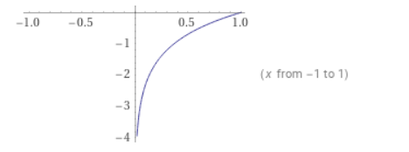
- g(x) = -ln(x)
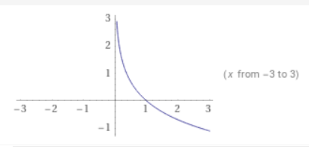
- h(x) = ln(-x)
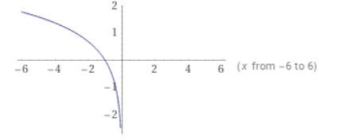
- i(x) = |ln(x)|
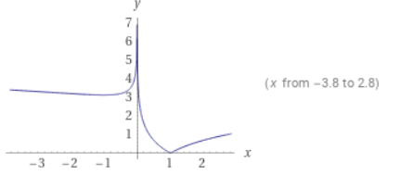
- j(x) = ln(x) + 2
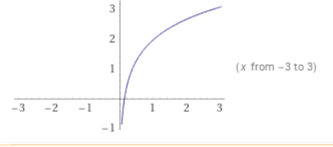
- k(x) = ln(x+2)
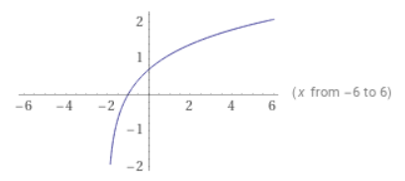
- l(x) = 2 ln(x)
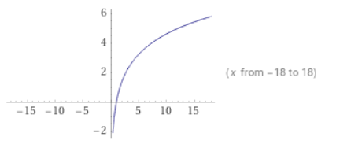
Priklad: zistite ci su funkcie proste a ak ano najdite k nim inverznu
- f(x) =(x^3-3)/(2+x^3)
2+x^3 =/= 0
X^3 =/=-2
X=/=3sqrt(2)
D(f) = R- {3sqrt(-2)}
f(x1) = f(x2)
((x1)^3-3)/(2+(x1)^3) … nestihol som, zistovali sme ci je prosta (je)
Teraz si vyjadrime inverznu
f^-1: f(x) = (x^3-3)/(2+x^3)
f^-1: x = (y^3 – 3)/(2+y^3)
2x+xy^3=y^-3
xy^3-y^3 = -2x-3
y^3(x-1) = -2x-3

- g(x) = (x^2 – 3)/(2+x^2)
2+x^2 =/=0
X^2 =/=-2 => D(g) = R
g(x1) = g(x2)
((x1)^2-3)/(2+(x1)^2) = ((x2)^2-3)/(2+(x2)^2
2(x1)^2+(x1)^2(x2)^2-6-3(x2)^2 = 2(x2)^2+(x2)^2(x1)^2-6-3(x1)^2
5(x1)^2=5(x2)^2 => nie je prostá

- h(x) = 5+ln(x+1)
D(f): (-1,nekonecno)
h(x1) = h(x2)
5+ln(x1+1) = 5 + ln(x2+1)
x1 = x2 = > je prostá
f^-1: x = 5+ln(y+1)
x-5 = ln(y+1)
e^(x-5) = e^(ln(y+1))
y+1 = e^(x-5) =>y = e^(x-5)-1

